Use Case Realisation Report - Register Volunteer Account
FOR
Volunteer Management System
(VMS)

CLIENT
PROJECT | Volunteer Management System (VMS)
TITLE | Use Case Realisation Report - Register Volunteer Account
VERSION | 0.2a
DATE | 13-Aug-2011
 | ORIGINATOR
 | Name / Signature | Team 8S
 | APPROVAL
 | Name / Signature | Phung Kim Cuong, Dio
Institute of Systems Science |  | Document Reference
25 Heng Mui Keng Terrence  Singapore 119615 |  | VMS/PM-1.4.1/1

 | Acceptance
 | Customer Signature |  | Customer Signature
 | Name & Designation |  | Name & Designation
 | Date & Company Stamp |  | Date & Company Stamp

Revision History

Date | Version | Description | Author
12-Jun-2011 | 0.1a | Creation | Team 8S
12-Aug-2011 | 0.2a | Updates | Team 8S

Table of Contents

1. Brief Description 3
2. Flow of Events 3
2.1 Standard Flow 3
2.2 Exceptions 4
3. Interaction Diagrams 5
3.1 Collaboration Diagram for Register Volunteer Account 5
4. Participating Objects 5
4.1 User 5
4.2 SecurityScreen 5
4.3 NAVMenu 5
4.4 HomeScreen 6
4.5 ExchangeServerIF 6
4.6 MainController 6
4.7 SecurityController 6
5. Class Diagram 6
6. Derived Requirements 6
ANNEX D Amendment History 7

Use Case Realisation Report - Register Volunteer Account

Brief Description
The use case describes the new volunteer account registration of VMS system.

Flow of Events
The standard flow of events for this use case and any exceptions are described in the following subsections. See section 4 for an overview of the participating Actors and Domain Objects.

Standard Flow
This use case provides the user interface related functionality that will be provided to the User, as follows:
To commence using the system functions, the general public can sign for a new account as follows:
- The User clicks ‘Register Volunteer Account’ URL on NAVMenu. The NAVMenu.registerVolunteer() will be triggered.
- NAVMenu.registerVolunteer() will use MainController.redirectURL() to rediect current screen to SecurityScreen.
- When SecurityScreen.show() is invoked, a new user input form will be displayed to enable user enter following information:
- Email address
- Password
- Full Name
- Date of Birth
- Gender
- Nationality
- Interests
- Language Proficiency
- Profession
- Contact
- Address
- When user click ‘Submit’ button, the SecurityScreen.OnSubmit() will use the SecurityScreen.validateFormat() to check the input info format.
- If the user info isn’t correct, SecurityScreen.displayMsg() is triggered to display the error message on the screen.
- If the use info is correct, SecurityController.createNewUser() method will be triggered.
- SecurityController.createNewUser() will use SecurityController.validateUserNamePassword() operation to validate use input.
- The SecurityController.validateUserNamePassword() use the getAllUsers() of User entity to get a list of registered users.
- If the user mail has already existed, SecurityScreen. displayMsg() is triggered to display the error message on the screen.
- If the user mail has not registered, the User.create() method of User object will be triggered to create a new object and save to database.
- The ExchangeServerIF.sendEmail() method is used to send an email to user.
- SecurityScreen.displayMsg() method is triggered to display the success message on the screen.
- SecurityController.createNewUser() will use SecurityScreen.close() to close the SecurityScreen()
- SecurityController.createNewUser() will use HomeScreen.show() to display HomeScreen upon the successful new account registration.
- The use case terminates.

Exceptions
The following exceptions have been identified:
- Invalid Password. If the new password doesn’t conform to the security format, system will prompt the format tips to assist users
- Invalid email address. If the email address is registered, system will prompt error message

Interaction Diagrams

Collaboration Diagram for Register Volunteer Account

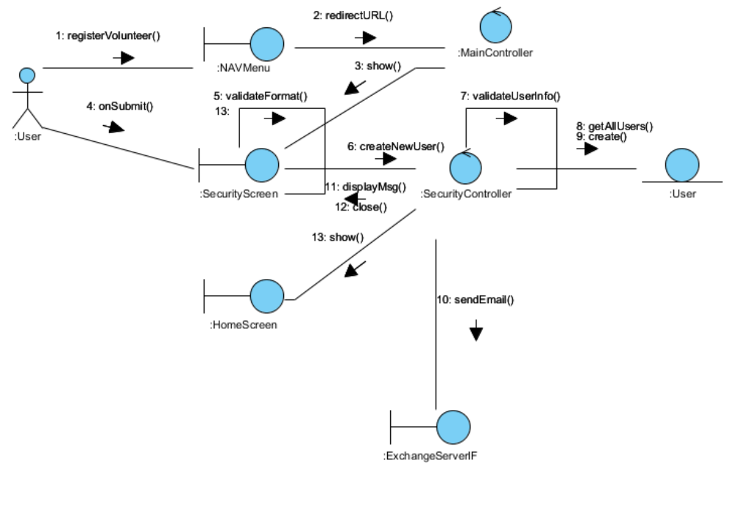
Figure 1 – Collaboration Diagram for Register Volunteer Account

Participating Objects

User
This entity object stores the details concerning a user of the volunteer organisation. The primary attribute that it holds is the userID.

SecurityScreen
This boundary object is used to display security form and exchange security information with controllers.

NAVMenu
This boundary object is used to display system navigation map for user account related operations.

HomeScreen
This boundary object is used for redirecting and displaying of home screen details and menu. All the user actors use this object.

ExchangeServerIF
This boundary object is used to interact with Microsoft Exchange Server and provide email service interfaces

MainController
This control object co-ordinates the menu selection and dispatches of requests of the volunteer management system. It delegates the user requests to the specific use case control objects for carrying out the use cases.

SecurityController
This control object co-ordinates the authentication, retrieval and update of security info

Class Diagram
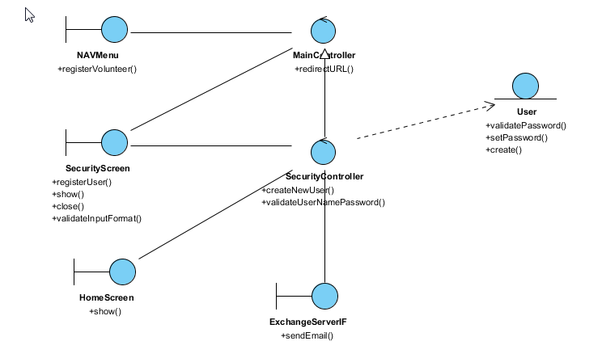
Figure 2 – Class Diagram

Derived Requirements
The User office PC (client system), keyboard and mouse will be used to process the project details and view all the system responses.

ANNEX D Amendment History

This is a record of all amendments made to the Document.
Version | Chapter / Section | Page No | Notes of Amendments or Changes

